Ryan Wooldridge

GES 419

**Are Low-Altitude Remote Sensing Technologies More Effective Than Traditional Survey Techniques For Monitoring Channel Change?**

River restoration projects, such as the removal of the Bloede Dam from the Patapsco River in September of 2018, require careful monitoring with respect to changes in channel morphology. A multitude of agencies and researchers are monitoring channel response over time at roughly twenty cross-sectional channel transects. However, this approach has several disadvantages, including the requisite costs of labor and time, personal risk, and perhaps its greatest disadvantage, a lack of information between transects. Though relatively new, Structure From Motion (SFM) technology from low-altitude aerial imagery provides a faster survey with less risk, and most importantly, continuous observation of the entire channel, allowing generation of digital elevation models (DEMs) based on real observations rather than interpolated values.

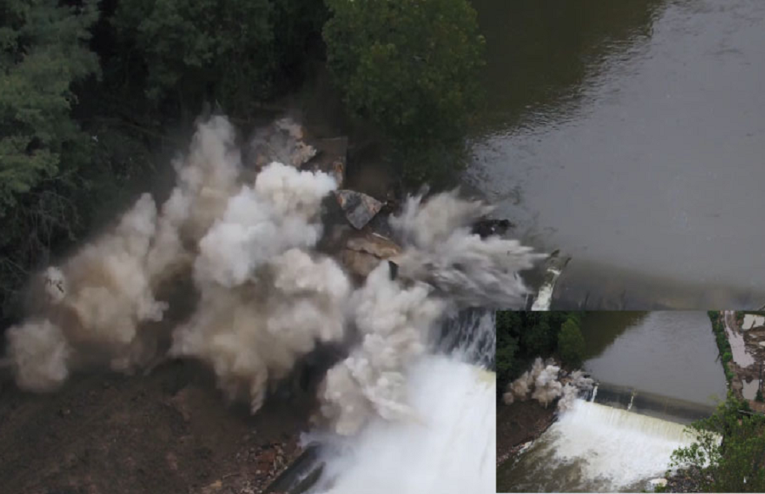

**Figure 1: The breaching of Bloede Dam in Sept 2018**

Continuous observation potentially makes SFM an extremely powerful tool for mapping channel change, not only over time, but in its ability to capture the effects of significant storm events. **Figure 2** depicts pre and post Ellicott City flood DEMs developed using SFM and their associated cross-sections. This figure demonstrates SFM’s ability to observe channel form change down to the scale of bars at any point in the stream. For example, the cross-section depicted by the red line clearly spans two distinct bars in the in the pre-Ellicott City flood DEM **(A)**. These same bars can be seen in the cross-sectional analysis beneath **(C)**, captured by SFM and represented as the blue line. This same red cross-section in the post-Ellicott City image **(B)** no longer span the distinct bars that were present in the pre-flood DEM, the lack of which can be seen in the profile of the orange line in the same cross-sectional analysis **(C)**.

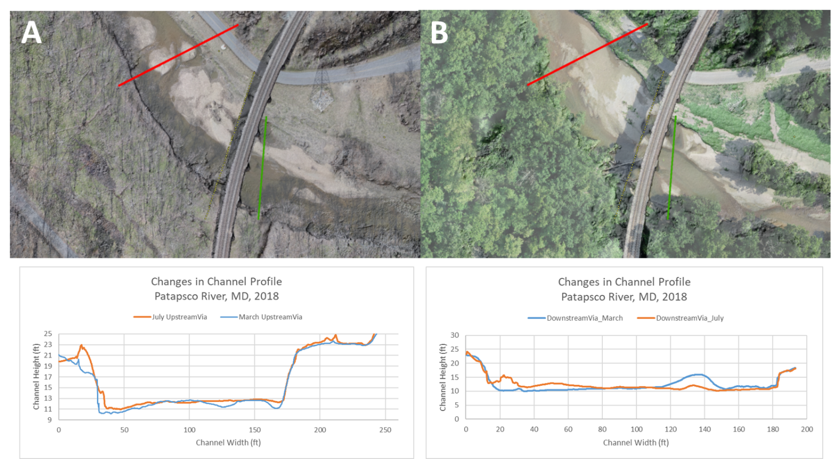**Figure 2: Cross-section comparison before (A) and after (B) the 2018 Ellicott City flood detected with ortho-image reconnaissance showing sub-aerial and bathymetric change that would have been missed by fixed transects.**

**D**

**C**

However, SFM also presents its own set of challenges, including photo-alignment, ground control point (GCP) identification and utilization, and obstructions of channel views by overhanging vegetation. Despite SFM’s potential to characterize channel changes in between conventional cross-sections, it remains unclear whether benefits from continuous mapping would offset the lack of precision in remote estimation. Thus we attempt to answer the following question:

Are low-altitude remote sensing technologies more effective than traditional survey techniques for monitoring channel change?

We conducted this research with the goal of quantitatively examining whether the continuous estimates produced by remote sensing more effectively capture channel change over large distances. In order to assess this question we chose a study area on the Patapsco River which begins immediately downstream of the Bloede Dam and continues for 4.7 miles downstream into the floodplain. The area described can be seen in **Figures 3A and 3B.**

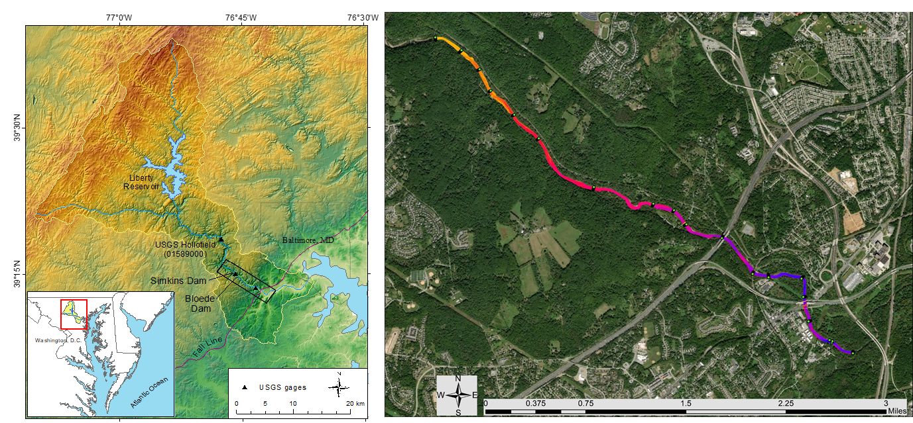**Figure 3: (A) Study region within the Patapsco River watershed; (B) SFM DEM of the study reach with transect locations.**

**B**

**A**

The first step in such an analysis was to determine the error in elevation associated with our SFM DEM relative to Maryland Geological Survey (MGS) ground truth point data. Using imagery obtained from low-altitude remote sensing technologies as seen in **Figure 4a**, as well as Structure From Motion software, we are able create three-dimensional Dense Point Clouds (DPCs) as seen in **Figure 4B**, from which digital elevation models can be derived. This process begins by aligning low-altitude drone imagery of the study area in Agisoft Photoscan and using a ground control point file to identify ground control points in the imagery, creating a georeferenced sparse point cloud. From this sparse point cloud, we can develop a dense point cloud and digital elevation model, both of which are also georeferenced. This is important because it allows us to compare the resulting elevation data to ground truth data. Since our newly produced digital elevation model is georeferenced in the same coordinate system as the MGS transect points, it is possible to export the DEM from Agisoft Photoscan, bring it in to ArcGIS, and use the **Extract Values To Points** tool to create an additional point file with the same X,Y coordinates as the MGS transects, but containing the elevation (Z) values associated with our newly created DEM. By exporting these elevation values, we can then analyze the difference in elevation between the original MGS transect points and the elevation values in the DEM created using Agisoft Photoscan. Specifically, by subtracting the elevation values of the original MGS transect points from the elevation values of the SFM DEM we can derive individual error values for each point. These individual error values can then be averaged to yield a Mean Absolute Error (MAE). Mean error, however, is confounded by positive and negative values cancelling each other out in in its calculation, thus the Root Mean Squares Error (RMSE) becomes a more informative statistic.

RMSE can be calculated using the following equation:

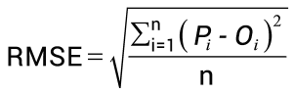

Previous comparisons following the aforementioned error analysis of SFM elevation values to surveyed MGS transect point data produced a MAE of 0.4ft and an RMSE of 1.2ft over 18 cross-sections and 1236 individual observations.

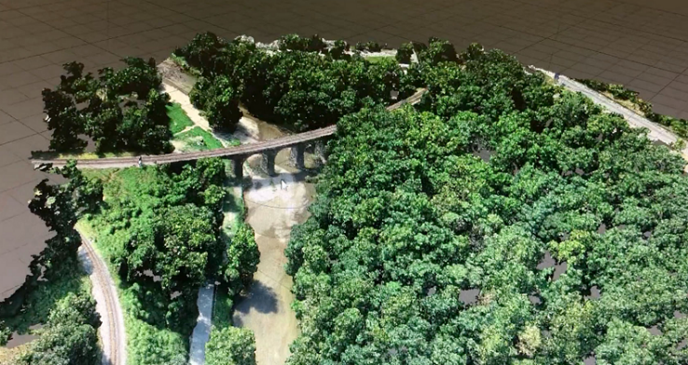

**Figure 4: (A) UAV used to document channel changes; (B) SFM point cloud of the channel at the Thomas viaduct.**

With an estimation of the elevation error associated with the SFM DEM relative to ground truth data obtained, the second portion of the analysis was to delineate the stream channel, the surface on which we would interpolate and compare elevation values between SFM and interpolated DEMs. This delineation was achieved through the use of geomorphon classification and ArcGIS. The resulting stream polygon is then rasterized and used as the bounds of the interpolations, as well as the comparison surface. Using the MGS transect points as the input point feature data, raster interpolation can now be performed. This same stream polygon was also converted to line work and the stream centerline was derived by using a function that collapses both sides of the channel line work. This output can be seen in **Figure 4A**. Distance values from the downstream outlet (s), as well as distance values from the centerline (n) were then assigned along cross-sections perpendicular to each centerline pixel using the Cost Distance and Cost Allocation functions. These same allocation zones serve as unique cross-sections which can be resampled using random selection with R programming in order to compare cross-sectional elevation data between SFM and interpolated DEM surfaces. Cross-sectional zones can be seen in in **Figure 4B**.

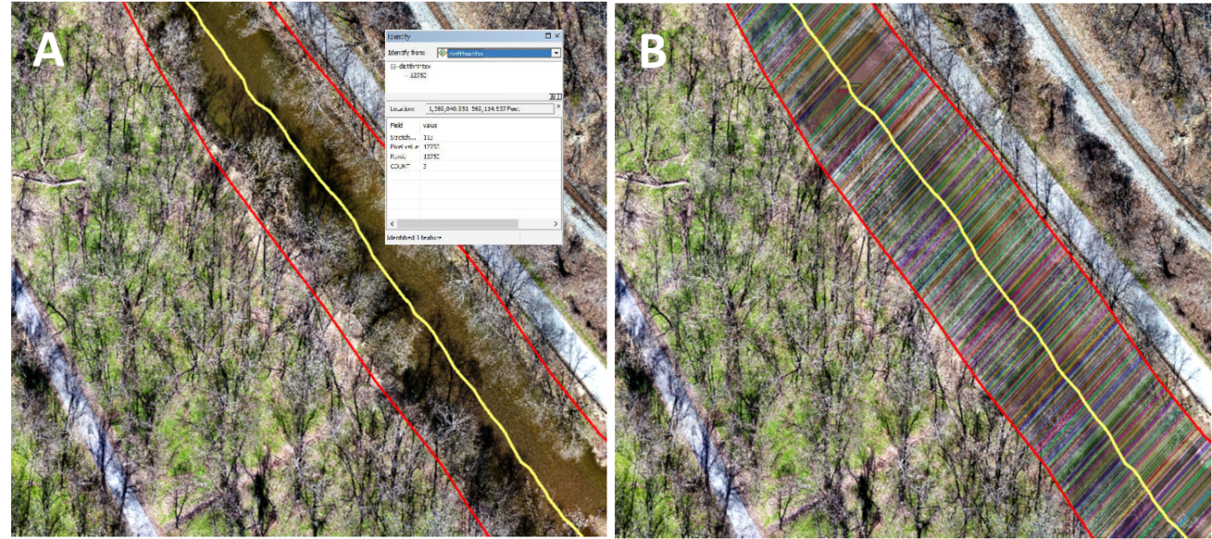

**Figure 5. (A) Stream Centerline with associated distance values; (B) Stream Allocation Raster.**

Using the previously mentioned random number selection function in R programming, we automate the evaluation of the differences between each interpolation’s elevation values and the SFM elevation values at random cross-sections between transects. Bootstrap resampling (500 replicates) are performed within each of 20 channel segments to estimate error across the study reach. Finally, MAE and RMSE were calculated from differences between each interpolation and the SFM DEM.

To assess efficacy of SFM techniques compared to cross-sectional data, we compared MAE and RMSE of two surfaces interpolated from transects to the MAE and RMSE associated with the SFM channel DEM that we calculated previously. However, interpolated surfaces created using Cartesian coordinates in previous research were problematic because they did not represent channel sinuosity, as seen below in **Figure 6**.

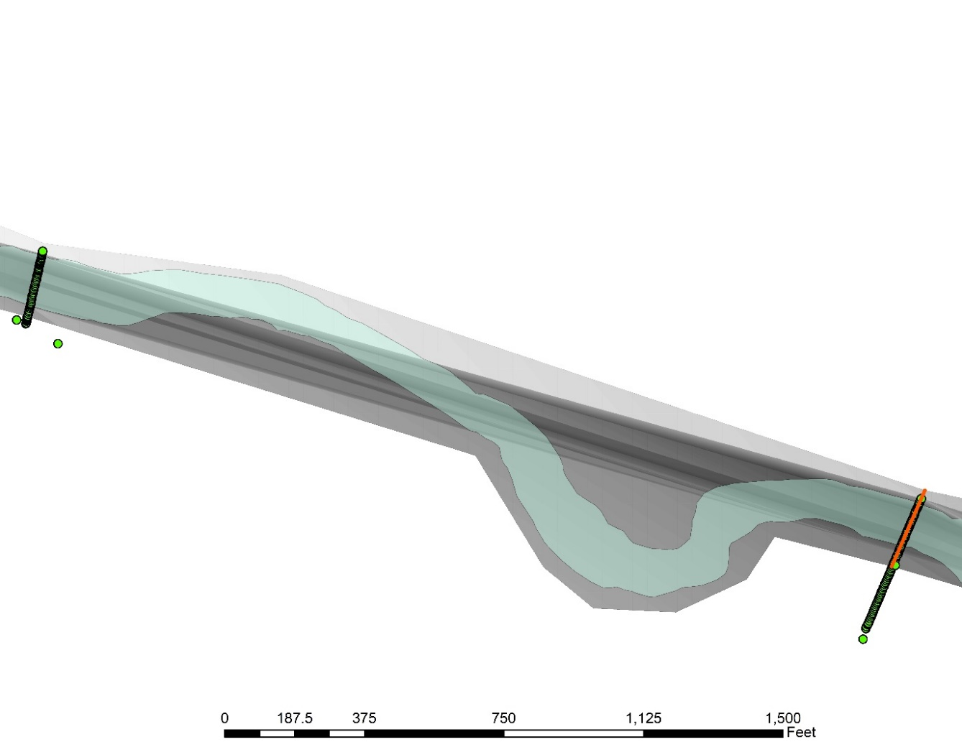

**Figure 6: TIN interpolation of channel using MGS transect data in standard Cartesian coordinate system. Interpolations failed to capture stream sinuosity, demonstrating the need for stream-centered coordinate system conversion.**

As a result, these Cartesian interpolated surfaces exhibited MAE and RMSE of greater than 1.5ft and greater than 5ft, respectively. These efforts, however, did produce the capacity to transform our data using a channel-centered coordinate system, effectively converting a sinuous surface to a straight surface on which interpolations could be performed, allowing for a more precise comparison. Specifically, we used the same coordinates derived from our distance from outlet (s) and distance from stream centerline (n) to convert both the SFM DEM and the transect points from a Cartesian coordinate system to a stream-centered coordinate system (s,n). The advantage of this conversion being that stream-centered coordinate systems essentially remove the factor of stream sinuosity, allowing for a straight surface on which to interpolate. Thus, with stream sinuosity essentially removed as a confounding factor, Digital Elevation Models (DEM) were generated from stream-centered transect point data using Natural Neighbor and Triangular-Irregular-Network (TIN) interpolation methods, the results of which can be seen below in **Figure 7**.

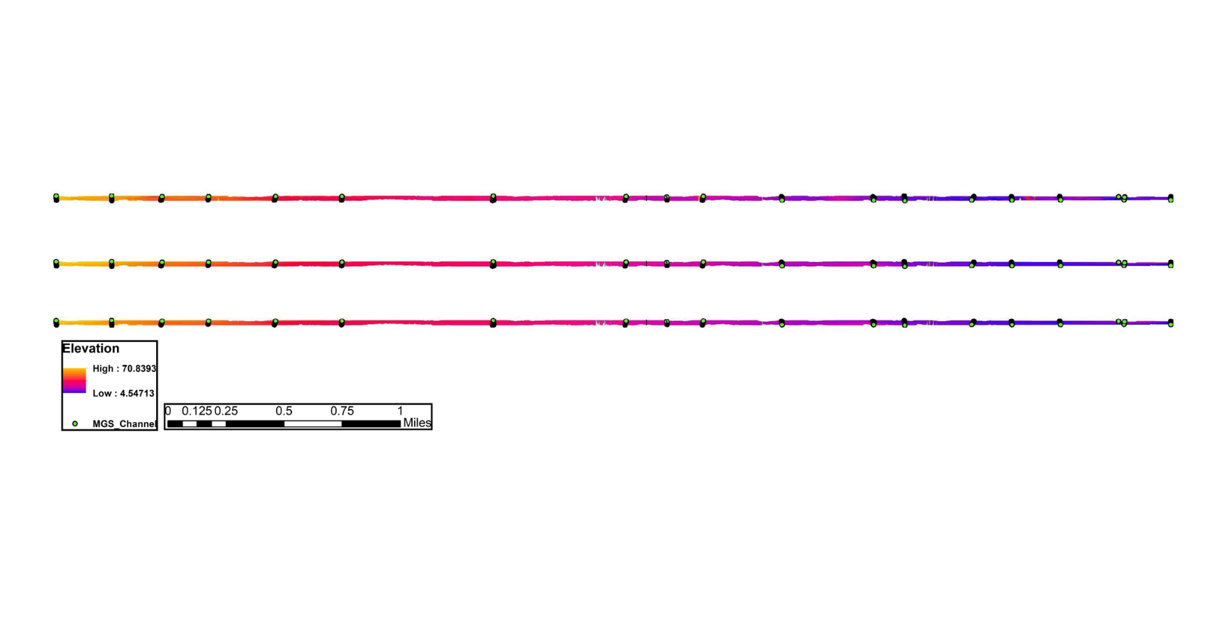

**Figure 7: DEMs of the channel within the study region derived from (A) SFM, (B) Natural Neighbor, and (C) TIN interpolation methods.**

A closer visual inspection of the results, shown below in **Figure 8**,reveals some noteworthy results. We see fairly strong agreement with regards to form and elevation at the MGS channel transects, although admittedly, this transect in particular had uncharacteristically poor error for SFM of nearly 2ft. However, a cross-sectional examination between transects leads to features of form which can be completely unrepresented by interpolated techniques. In particular, we observe a raised elevation at the cross-section in between transects in the SFM DEM **(8A)** in the form of what appears to be a bar that is not well represented in the interpolated DEMs **(8B and C)**. As stated previously, however, it is not immediately apparent whether these detailed observations in between transects offset the lack of precision observed in our SFM DEM and make SFM a more effective method of capturing channel change. Thus we must examine the results of our quantitative analysis.

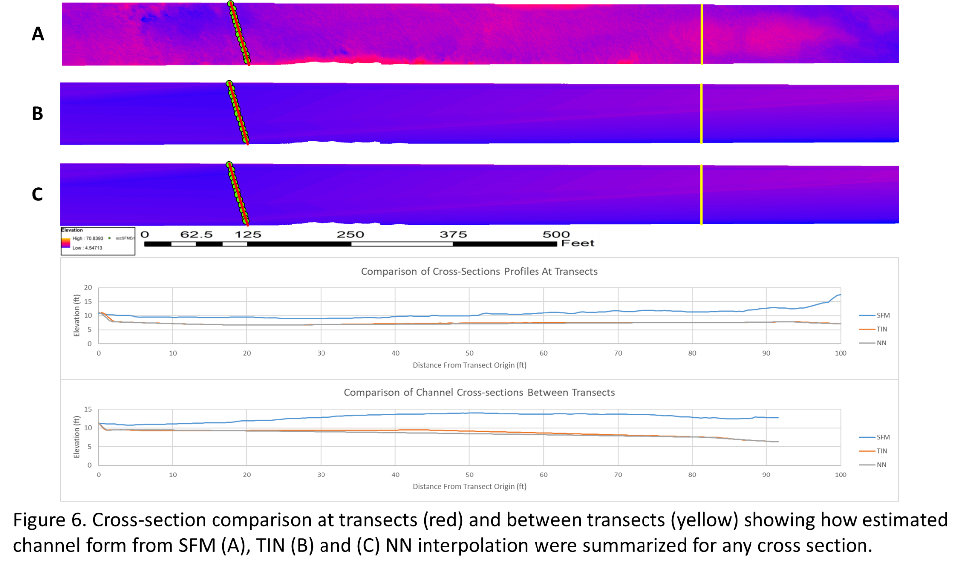**Figure 8. Cross-section comparison at transects (red) and between transects (yellow) showing how estimated channel form from SFM (A), TIN (B) and (C) NN interpolation were summarized for any cross section.**

Initial exploration indicates SFM from low-altitude remote sensing is substantively more effective at representing channel morphology than interpolation from fixed transects, despite lack of precision. Both TIN and Natural Neighbor interpolations resulted in MAEs of less than 1ft, comparable to the 0.4ft MAE observed when comparing SFM elevations to MGS field survey data. Specifically, the mean difference of elevation values from SFM associated with the Natural Neighbor interpolation returned a MAE value of 0.13ft, while TIN interpolation yielded 0.58ft. Low MAE values are to be expected, and indeed were observed even in the previous iterations of this research involving interpolated surfaces derived using Cartesian coordinate systems. This is due to the fact that many positive and negative error values cancel each other out when simply averaging error. In **Figure 9A** we see the results of overall mean difference of elevation values from SFM. We also observe some extreme outliers from the SFM values. These can also be seen in **Figure 9B**, which examines mean differences of elevation from SFM values by stream segment, allowing us to determine their relative position in the stream. Examination of these outliers revealed areas where the SFM DEM observed bridges and recorded the associated elevation values. The cross-sections can be removed to improve future iterations of this analysis.

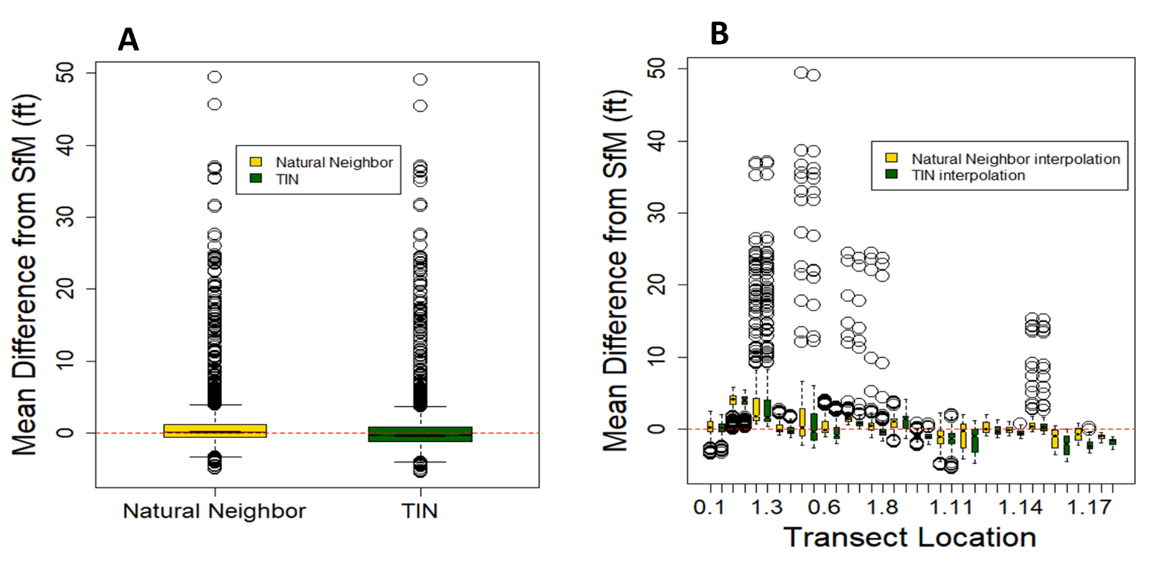

**Figure 9. (A) Mean difference from SFM of elevation values. Natural neighbor interpolation (yellow) produces a mean difference of 0.13ft, while TIN interpolation (green) produces a mean difference of 0.58ft. (B) Mean differences from SFM of elevation values by stream segment.**

RMSE addresses the shortcomings of MAE by essentially taking the absolute value of each error value in the summation portion of the average to give, for our purposes, a more meaningful view of the error contained within the interpolated DEMs. As seen in **Figure 10**,both TIN and Natural Neighbor interpolations resulted in RMSEs of mean elevation differences greater than 3ft, much larger than the 1.2ft RMSE observed when comparing SFM elevations to MGS field survey data. In fact, our results show that the RMSE of both interpolated surfaces is nearly three times higher than that of the observed RMSE associated with the comparison of SFM to ground truth data. This would seem to indicate that SFM DEMs derived from low-altitude remote sensing imagery are significantly more effective at representing channel morphology than interpolation from fixed transect point data, despite the relative lack of precision.

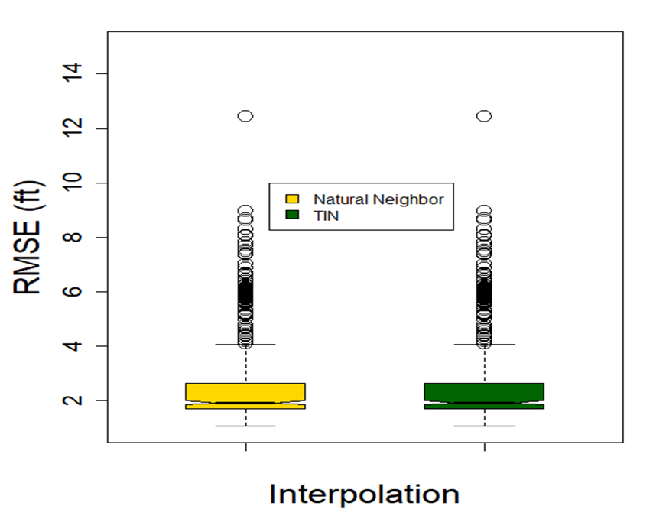

**Figure 10. RMSE of mean elevation differences of 500 bootstrap replicates across 20 channel segments. Natural Neighbor Interpolation (yellow) produces an RMSE of 2.60ft, while TIN interpolation (green) produces an RMSE of 2.51ft.**

It is important to note, however, that while we did successfully transform the maps using a stream-centered coordinate system and perform a more accurate comparison, surfaces created using our channel-centered coordinate system can be further improved using a more precise stream centerline, and this will be the next step in our research. Further, recent image acquisition more than six months since the dam removal, and again coincident with field surveys, will allow for a more accurate assessment of the ability of both SFM and cross-sectional data to represent changes through time.